Walkersville Evangelical
Presbyterian Church

March 2, 2025, 10:00 a.m.

Prelude

Greeting & Announcement

*Call to Worship #340
“Turn Your Eyes Upon Jesus”

*Prayer

*Hymn #755
“We Shall Behold Him”

*Prayer of Confession
Almighty God,
In the grace and mercy we find at your Table, we pray for healing and nourishment. Help us examine our hearts, be obedient to your commands, and gain strength to follow the example of our Lord and Savior Jesus Christ.

*Silent Confession of Sin

*Assurance of Pardon
Our God has cleansed and forgiven us, enabling us to approach his Table with praise.

*Gloria Patri We will Glorify
We will glorify the Father, We will glorify the Son,
We will glorify the Spirit, God Almighty three in one.
As He was in the beginning, so He is eternally,
God unchanging, never wavering, holy, loving Trinity.

Children’s Moment

Offertory Choir

*Doxology & Prayer #814

Sermon: “The God of Relationship”
Scripture: Revelation 21:3

Prayer

*Hymn Back of Bulletin
“In Christ Alone”

Invitation to the Lord’s Table

*Affirmation of Faith Back cover of hymnbook
“Apostles’ Creed”

*Hymn #757
“Soon and Very Soon”

*Benediction

*Those who are able, please stand.
In Christ Alone
In Christ alone, my hope is found
He is my light, my strength my song
This Cornerstone, this solid ground
Firm through the fiercest drought and storm
What heights of love, what depths of peace
When fears are stilled, when strivings cease
My Comforter, my All in All
Here in the love of Christ I stand

In Christ alone, who took on flesh
Fullness of God in helpless babe
This gift of love and righteousness
Scorned by the ones He came to save
‘Til on that cross as Jesus died
The wrath of God was satisfied
For every sin on Him was laid
Here in the death of Christ I live, I live

There in the ground His body lay
Light of the world by darkness slain
Then bursting forth in glorious Day
Up from the grave He rose again
And as He stands in victory
Sin’s curse has lost its grip on me
For I am His and He is mine
Bought with the precious blood of Christ

No guilt in life, no fear in death
This is the power of Christ in me
From life’s first cry to final breath
Jesus commands my destiny
No power of hell, no scheme of man
Can ever pluck me from His hand
Till He returns or calls me home

Walkersville Evangelical
Presbyterian Church

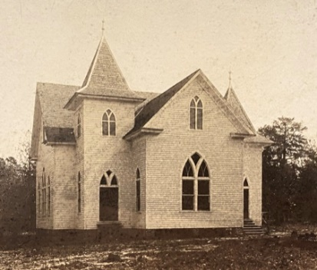

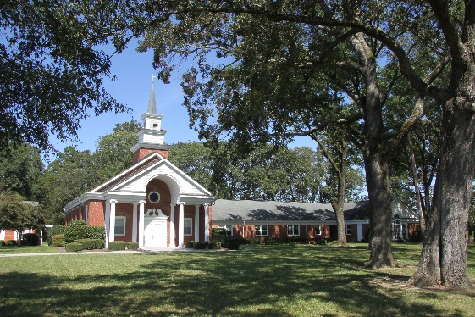

Sunday, March 2, 2025, 10:00 am

